Cloud Drive

S. R. S. Report– I

7th Oct, 2017

*Prateek Agrawal*

*Shalabh Chaudhary*

Table of Contents

Table of Contents 1

1. Introduction 3

1.1 Purpose 3

1.2 Product Scope 3

1.3 Glossary 3

1.4 References 3

1.5 Overview 3

2. General Description 4

2.1 Product Perspective 4

2.1.1 System interfaces 4

2.1.2 User interfaces 4

2.1.3 Hardware interfaces 4

2.2 Product Functions 5

2.3 Enterprise Requirements 5

2.4 User Characteristics 5

2.5 Constraints 5

2.6 Assumptions and Dependencies 6

3. Specific Requirements 6

3.1 Functions 6

3.2 Use Case 7

3.2.1 Goal in context 7

3.2.2 Scope 7

3.2.3 Preconditions 7

3.2.4 Actors 7

3.2.5 Main success scenrio 7

3.2.6 Diagram 8

3.3 Data Flow Diagram 9

# Introduction

## Purpose

The purpose of this document is:

* To state the requirements for the Cloud Drive in a way that allows tracing from the original (ambiguous, unrefined) form to the analyzed and refined form.
* To show the analysis of the requirements (dependencies, issues resolved, how the requirements have been understood, etc.)

Therefore, this document is more than a requirements specification – it is also a statement of how the requirements were derived from the input, and how the requirements relate to each other.

## Product Scope

The product is a software application which runs on Linux and Windows desktop.

## Glossary

This subsection contains definitions of all the terms, acronyms, and abbreviations used in the document. Terms and concepts from the application domain are defined.

## References

* IEEE 830-1998
* Project Documentation, by Prateek Agrawal

## Overview

This document is laid out in a modified IEEE830-1998 style. The biggest difference from the standard is the addition of section 4, which describes the process used to produce this document. The following information is in this document:

* Section 2: General description of product, including user interface screen shots, dependency analysis, and enterprise requirements.
* Section 3: Functional & Non-functional requirements. Note that all non-functional requirements are grouped into one category, and not distributed among categories, as in IEEE830. Section 3 also covers use cases and deleted requirements.
* Section 4 describes the requirements analysis process.

# General Description

This is a client for Google Drive. This application will be cross platform. Google.lnc has not provided any client for Google Drive for Linux platform till now. A package will be provided to user and user need to install it. After installing, a folder named Cloud Drive will be created in home folder (In Linux), a folder will be added to quick access (in Windows). User need to sign up or sign in to his Google account and application will have access of his Google drive to update, delete, add the files on cloud.

Python3 and Pip must be preinstalled on the operation system. The user needs to give exception in firewall (if any) and the system must support to network connections and HTTPS protocol.

All offline available files will be automatically synchronized to his Cloud Drive folder and the newly created files or folder will be uploaded to cloud. Synchronization will be done automatically when the device will be connected to internet.

## 2.1 Product Perspective

The Cloud Drive which needs PyQt5. On the Windows platform and Linux Platform, PyQt5 doesn’t come preinstalled. So it will be installed while user installs the application.

### 2.1.1 System interfaces

As stated in section 2.1 Cloud Drive relying on very little in the way of external software interfaces. However, the system will require interfaces with the installed computer’s hardware. The system is to be a web-enabled system, meaning that all user interaction is done through a web browser. The System interfaces required on the system server are the following:

* Network interface to a network with an internet connection.

### 2.1.2 User interfaces

* All user interfaces other than initial installation occur at time of installation.

### 2.1.3 Hardware interfaces

* There are no hardware interfaces to this system.

## 2.2 Product Functions

The Enterprise functional & non-functional requirements have been analyzed and all issues and ambiguities resolved. This document is for review by Prateek Agrawal, who is the owner of Cloud Drive.

See section 4 for the process used to analyze the requirements, and to generate the modified enterprise requirements below. Each requirement below has a trace back to the line number in the original requirements specification, which is shown in section 4.

### 2.3 Enterprise Requirements

This product doesn’t need special requirement to use on Enterprise purpose but this product cannot be sold.

## 2.4 User Characteristics:

There are three types of users in this system. The first one will be the clients who are authorized users (who have been log in into their Google account gave the permission to modify, access, delete and create the files in their Cloud (Google Drive)). The second one will be the clients who are non- authorized users (who have been log in into their Google account but didn’t give the permission to modify, access, delete and create the files in their Cloud (Google Drive)). The third one is the administrator, who is able to see the activities threw Google analytics to make this product better.

All authorized users can see their activities but they cannot see other’s activities.

All non- authorized users neither can see their activities nor can see other’s activities.

All users have to have basic computer skills which include working with Linux or Windows. Since all interaction with the UI of the system is through a terminal or Preferences, the system cannot be used without access and knowledge of Linux or Windows.

## 2.5 Constraints

There are a number of constraints which the system must abide. The system must be developed within their bounds. These constraints dictate a number of the functional and nonfunctional requirements specified by this document.

* System is to be developed in Python and use Google API.
* Data and logs must be stored in the files which will be encrypted so that no one can see

them.

* User credentials must be stored in encrypted form which will be hidden.
* Some users are authorized users while some are non-authorized users. Non-authorized users can not see other user’s preference and activities.
* System must handle rescheduling meetings with no outside input from initiator unless conflict arises.
* Server-Client communication must be done over HTTPS connections for security purpose.

## 2.6 Assumptions and Dependencies

* Application will be installed on a machine running either Windows operating system or Linux.
* Pip and Python3 must be preinstalled on the system.
* Network adopter must be available and enabled in the system.
* The system must be supported to established HTTPS connections.
* The user must have a Google account and storage available in Google Drive.
* The application must be non- blocked by firewall (if available).
* A secure internet connection must be available in the system and user should have access to that.

# 3. Specific Requirements

This section specifies the detailed requirements which the system shall meet.

## 3.1 Functions

System functional requirements are specified by use cases and specific requirements. The use case helps understand system behavior, and the specific requirements extend the information from the use case.

### 

### 3.2 Use Case:

### -----------------------------------------

**CHARACTERISTIC INFORMATION**

**3.2.1 Goal in Context**:

The Authorized user’s now can create or delete files and it will be synchronized to cloud. If the user isn’t logged in then it is not possible to create, modify and delete the files.

Administrator can see the basic details of Authorized users.

**3.2.2 Scope**: Maintain Files On Cloud

**3.2.3 Preconditions:**

User has an account & has logged in successfully. User is not the administrator. So they can’t see the details of other users.

**3.2.4 Actors:** Authorized users, Non- authorized users, Administrator

----------------------------------------

**3.2.5 Main success scenario:**

1. Application shows and enables the following options and operations for Authorized users:
   * Create files
   * Delete files
   * Modify files
   * Share files with others
   * Access files
   * Contact to owner
   * Logout
2. Application shows and enables the following options and operations for Non- Authorized users:
   * Contact to Admin
   * Login
   * check for newly arrived invitations
   * logout
3. Administrator or owner of the application can have the following options:
   * Access basic details of users

**3.2.6 Diagram:**

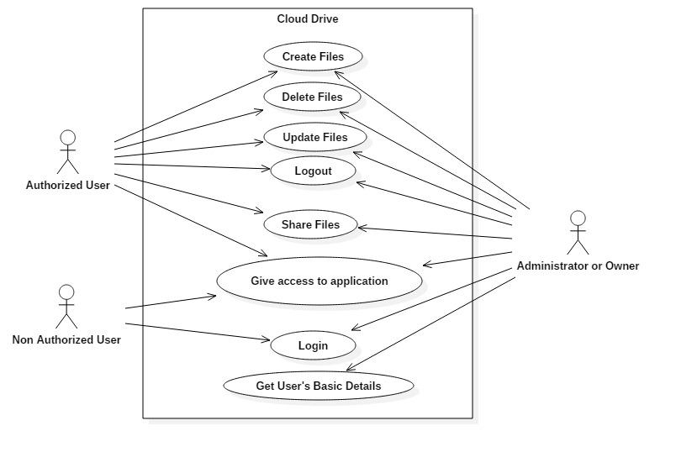

**3.3 Data Flow Diagram:**

